Guidelines for Completing Answer Grids
Spring 2019 MCAS Paper-Based Mathematics Tests
for Grades 3–5
Parts of an Answer Grid
How to Complete an Answer Grid in Grades 3–5:
- Work the problem and find the answer.
- Write your answer in the answer boxes at the top of the answer grid.
- As long as there are no spaces within the digits of your answer, you may print your answer on the left side, the right side, or in the middle of the grid. Make sure there are no spaces within the digits of your answer.
- Print only one digit or symbol in each box.
- Do not leave a blank box in the middle of your answer.
- Fractions cannot be entered into an answer grid. Enter fractions as decimals.
- Be sure to write a decimal point in its own answer box if it is a part of your answer.
- In larger numbers, do not use commas since there is no way to fill in a bubble for a comma.
- You may include leading zeros in decimal answers but you are not required to do so.
- Other than a leading zero in a decimal, do not add any other zeros to your answer.
- Under each answer box, fill in the circle that matches the number or symbol you wrote above.
- Make a solid mark that completely fills the circle.
- Do not fill in a circle under an unused answer box.
- You must fill in the circles accurately to receive credit for your answer.
- If you need to change an answer, be sure to erase your first answer.

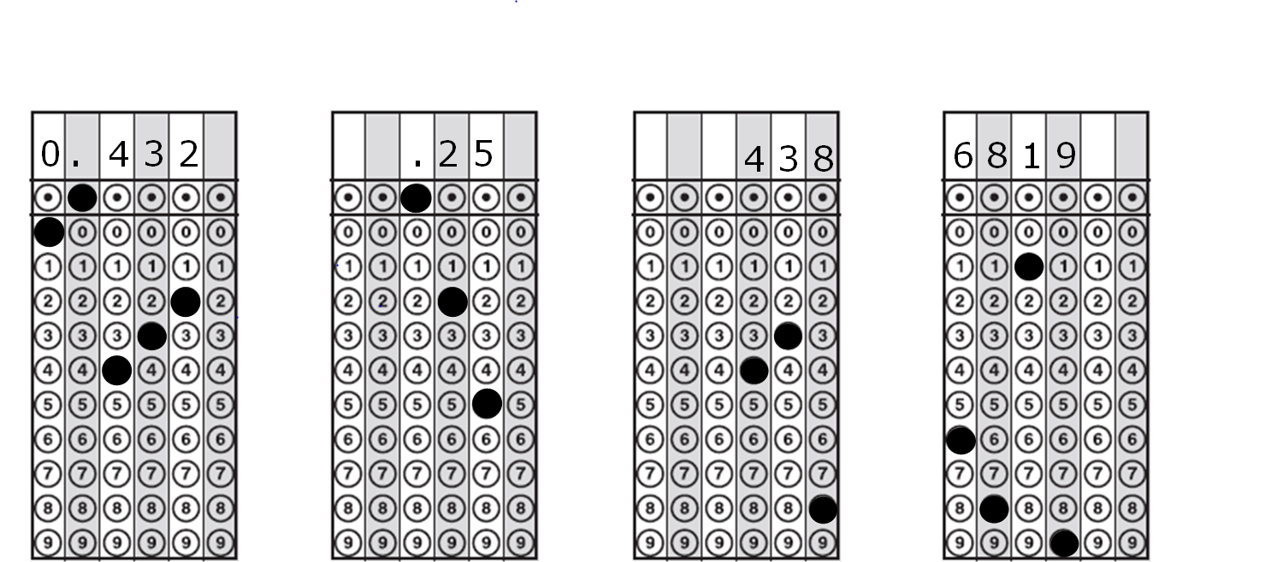
Examples of How to Correctly Complete an Answer Grid in Grades 3–5:
. 2 5
0 . 2 5

